Project Planning Phase Milestone and Activity list

|  |  |
| --- | --- |
| Date | 24 October 2022 |
| Team ID | PNT2022TMID51704 |
| Project Name | Retail Store Stock Inventory Analytics |

**Milestone TimeLine chart**

* A milestone chart is a tool that is used for scheduling and visually displaying the important dates or events in a project.
* By breaking down the project timeline into different stages with a milestone chart, we can simplify and track the completion or start of project milestones.
* A milestone chart is a way to visualize the most important steps of the project.
* Each milestone the team achieves brings us closer to completing our project—in this way, milestones provide a sense of accomplishment and shows the team how the work is progressing and how close to the project.
* A timeline tool is easy to set up and maintain, especially whenever the team has to add new tasks or adjust milestones

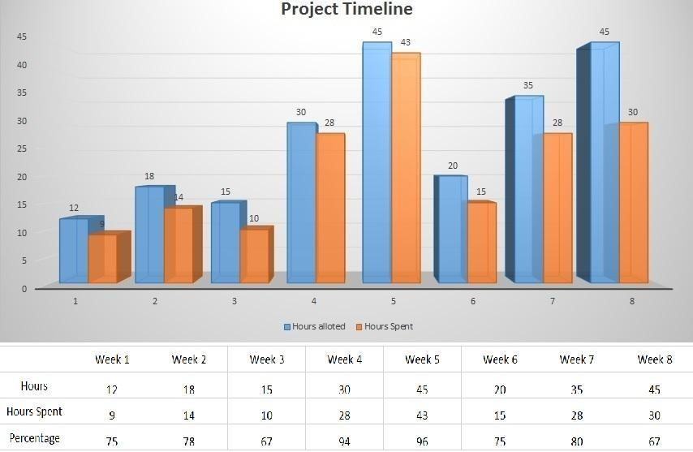

|  |  |  |  |  |  |  |
| --- | --- | --- | --- | --- | --- | --- |
| **Milestone** | | | **Activity** | **Description** | **Date** | |
| Working with the  Dataset | | | Understanding The  Dataset | Understand the dataset to provide  better visualization. | 29 Oct 2022 | |
|  | | | Loading the Dataset | Load the dataset into the IBM  Cognos. | 29 Oct 2022 | |
|  | | | Prepare the dataset | Prepare the dataset in the IBM  Cognos. | 29 Oct 2022 | |
| Data visualization  charts | | | Year Wise Price Using  Line Graph | Visualize the year wise price  using line graph in IBM Cognos. | 05 Nov 2022 | |
|  | | | Year Wise Stock Using  Line Graph | Visualize the year wise stock  using line graph in IBM Cognos. | 05 Nov 2022 | |
|  | | | Top10 Sales By Year Using Line Graph | Visualize the top10 sales by year  using line graph in IBM Cognos. | 05 Nov 2022 | |
|  | | | Monthly Sales Using  Tree Map | Visualize the monthly sales using  Tree Map in IBM Cognos. | 05 Nov 2022 | |
|  | | | Monthly Revenue  Using Pie Chart | Visualize the monthly Revenue  using Pie Chart in IBM Cognos. | 05 Nov 2022 | |
|  | | | Summary Cards of Total Revenue, Sales, Stock, Price | Visualize the summary cards of total Revenue, Sales, Stock, Price in IBM Cognos. | 05 Nov 2022 | |
| Dashboard | | | Dashboard Creation | Create Dashboard for various  visualization in IBM Cognos. | 12 Nov 2022 | |
| Report | Report Creation | | Create Report to visualize detailed  report of sales, stock, price in IBM Cognos. | | 19 Nov 2022 | |
| Story | Story Creation | | Create story to make on the data  in IBM Cognos. | | 19 Nov 2022 | |